## The Path Text Tool

Just as the name implies, this tool allows you to create text fit to follow a path. It is used as a hybrid of a spline and text tool.

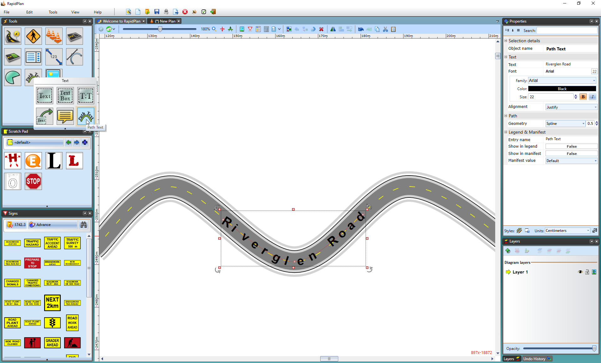

The_Path_Text_Tool